PROJECT MANAGEMENT Due date week 6(March 8th).

**Competitor Analysis.**

Rating 1-5 (1=bad, 2=poor, 3=fair, 4=good, 5=outstanding)

|  |  |  |  |  |
| --- | --- | --- | --- | --- |
|  | SUE CONNOR ARCHITECTS |  | ENVIROTECTURE |  |
| **Home Page-**  How informative is the Home page?  Does it set proper context for the user?    How fast does it load? | Some info on what they do- strong emphasis on sustainability  Yes –Although the home page displays a forest as the hero image, emphasising their mission, rather than a building. Clean simple design. Not too busy. Each page has hero images not directly linked to architecture. (i.e.- projects has an image of yachts as the hero)  Load is fast | 4  4  5 | Very- has a carousel hero image plus other sections for different types of projects  Yes - it does. The design is simple, bordering basic  Load is fast | 5  5  5 |
| **Navigation-**  Is it consistent?  Does it make sense? (IA) | Yes, it is consistent. 6 nav tags. No dropdown menus  Yes- very simple with only 3 nav tags/pages | 4  5 | Yes - stays the same throughout-7 nav tags (however the bolding of nav tags on hover means it moves).  Lots of subheadings. Gives plenty of options, maybe too many. | 3  4 |
| * **Links/Labels** * Are the headings easy to understand? * Are links just generic or clear indicators of what is behind? | Yes  Clear.  One thing I noticed was that on clicking on a thumbnail you're taken to a gallery but there's no back or close button | 2  4 | Yes- mostly since there are so many especially in the dropdown menus.  Very clear with lots of different paths for the user to take to get to each part of the site. | 5  5 |
| **Search-**  Is there a search facility within?  Do the search findings make sense? | No search facility  N/A |  | No search facility  N/A  . |  |
| **Readability/ Accessibility Issues-**  Is the content easy to read?  Is it easy to scan?  Are line lengths ok? | Body copy is 18px -line height 1.6- easy to read.  Some body text links (about page) use #229883-fails WCAG aa / WCAG AA contrast checks  Yes. due to a line character length of 53characters.  (body max width 800px) | 4  4  4 | Body copy 16px, P tags have line height 24px plus margin bottom 20px-  Some of the body text links are written in #5e9e50 – this failed a contrast checker. (some scattered throughout, and the awards page is all in ##5e9e50  Mostly ok  Some line lengths are 143 characters | 2    4  3 |
| **Site Performance-**  Does it load quickly? | yes | 4 | yes | 4 |
| **Content-**  Does the content meet audience expectation?  Is the site content favouring in-depth material? | Yes, it does.  Only has real content. | 4  4 | Yes, it does- plenty of info.  It is quite complex in terms of information, blog, newsletter etc  Yes. | 5  4 |
|  |  | 52 |  | 54 |

**Site map evaluation of competitors**

Investigation how the competition is doing it-

SUE CONNOR ARCHITECTS- Site map.

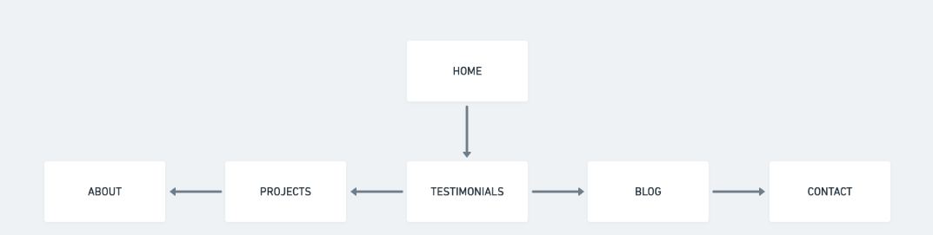

Nav- HOME, ABOUT, PROJECTS, TESTIMONIALS, BLOG, CONTACT. (contacts & socials are in footer)

ENVIROTECTURE- Site map.

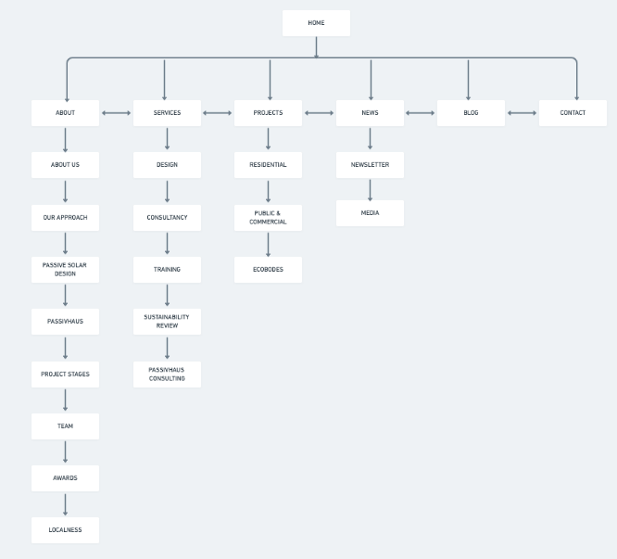

Nav- HOME, ABOUT, SERVICES, PROJECTS, NEWS, BLOG, CONTACT. Social is above nav and in footer, contacts in footer plus on contact page

**Questions for client.**

1. **Who is your target audience?**

We want to appeal to a varied audience as we work on different types of projects- residential, commercial, restoration and fit-outs. Also, as our projects are environmentally conscious, we would like that to be a major focus of the site. We want to appeal to a broad spectrum of user/customer who would feel inspired to use us as their architects on their next build. The site needs to be simple to navigate and appear friendly to those wanting residential work done but also, we would like it to be impressive enough to inspire more clients within the commercial area.

2. Who do you consider to be your main competitors?

We would say Sue Connor Architects & Envirotecture as they both do different types of projects and are environmentally aware, as are we. What we would like to have is something that sits in line with these taking the best of each of them.

3. What is your point of difference- what sets you apart?

Although our work could be considered similar to those websites mentioned above, our range of works is greater and we have many awards that we would like to highlight as a potential draw for more contracts.

4. Can you provide some details of websites that you like or feel inspired by? (these don’t need to be architecture websites)

We want to focus on what our competition are doing so that we can place ourselves correctly. We like the simplicity of Sue Connors website but feel that we might like more options for the site such as dropdown menus. By comparison, Envirotectures site feels cluttered although it does have a lot of information. We also like Bent Architecture and Perkins &Will as these both feel like they have a more elevated stylish look.

5. What do you like / don’t like about the current site?

We don’t like the logo-it needs a revamp. Plus, a tagline added. We will need the full name not just ADA as it has caused issues when being searched for (we’re not a dental practice). We would like to feature the team on the site. We also feel that the current site is a little static so would like to see some movement on it.

6. What do you think your audience feels would be of value to them to have on the website? Have they been asked/involved?

* A lot of people have mentioned that the site currently gets confused with the Australian Dental Association when they search for us on the internet. We feel that with re-branding this issue could be solved. Also, maybe a profile section /page of staff members so that customers can view who might be best suited for their project- we have a lot of contact from customers not knowing who they need to engage. (this might make it easier for them).
* No, we haven’t asked

7. You mentioned that your Twitter account isn’t generating any business for you but that you would like to incorporate social media to promote your business-

* Why do you think Twitter isn’t working for you and what kind of content are you wanting to share on social media?
* Would you be open to other platforms to reach different audiences?
* do you have any other social media accts linked to the business and why have you chosen them?
* We're not really sure
* Yes, definitely- anything that would help boost the business
* Not at the moment, just Twitter.

8. What is the deadline for this project?

Ideally, we would like to have this finished by May 28th 2021. (3 months)

9. What have you allocated for the website build?

We have allocated $5k as a max for the build. We would be open to discussion if the scope changes and would like to be able to have further updates managed by you, obviously this would need to be negotiated as to whether it would be included and for how much/ how long or as am ongoing retainer.

**MSCW**

Using the information extracted from the interview with the client I determined what Must, what Should, what Could and what wouldn’t be within the website-

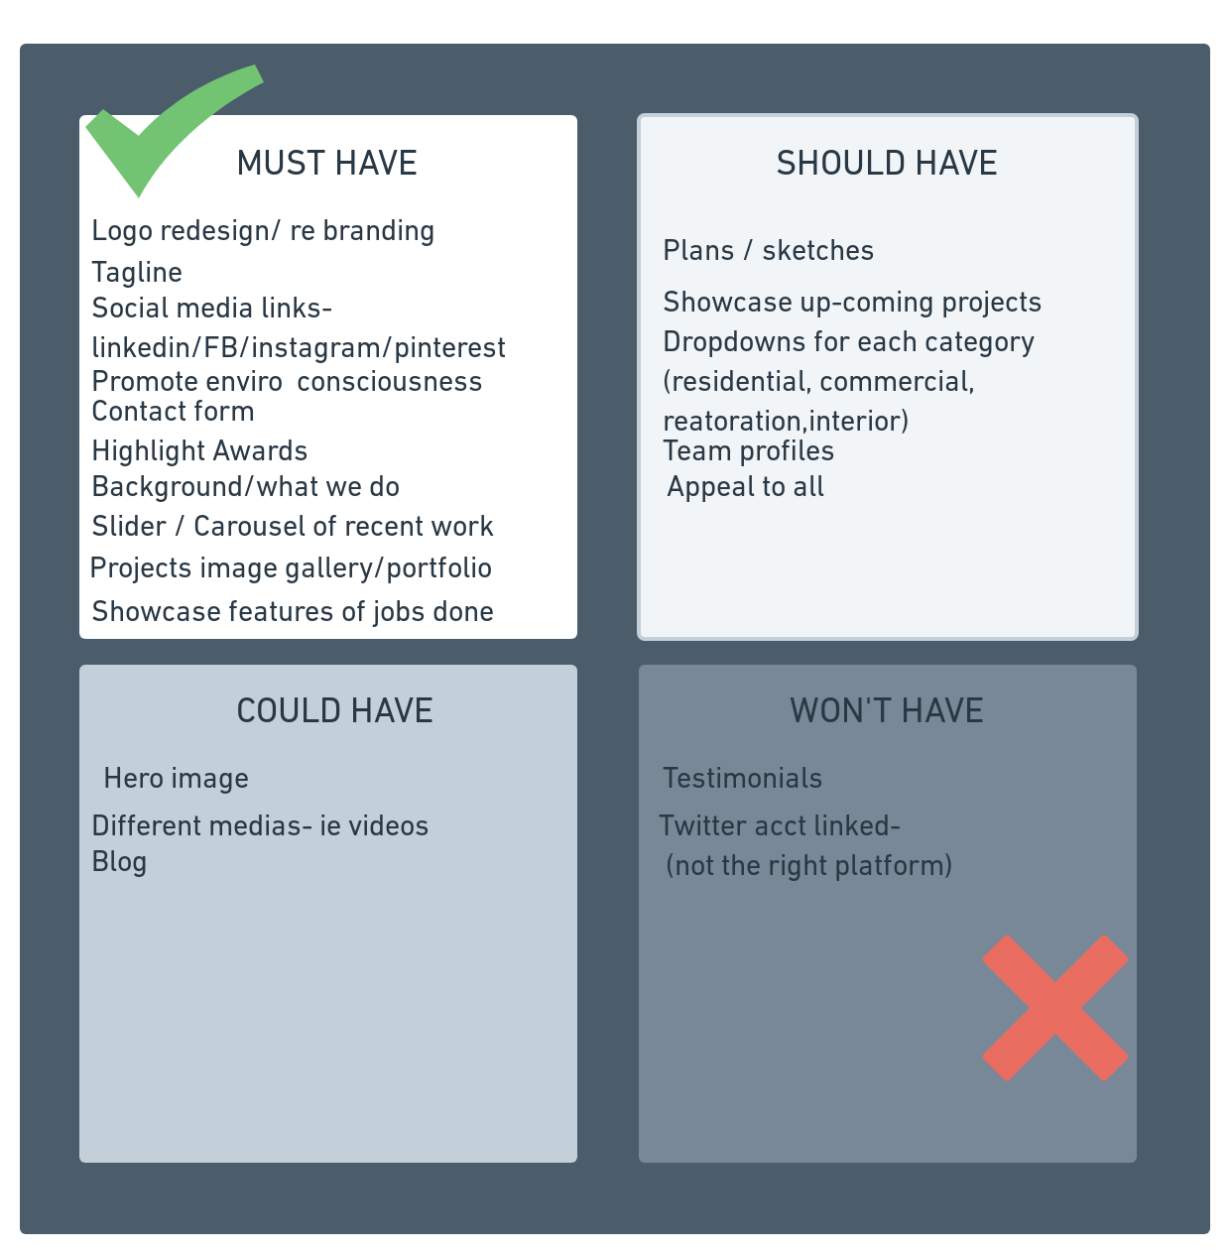

For inspiration, I wanted to see what some high-end architecture websites are doing with their navigation.

I found these which are incredible and proves that it doesn’t **always** just have to be the same linear navigation that we usually see. It shows a great use of design within a design website. I also wanted to investigate what labels were being used in their navigation to ensure it would feel like a fresh new site.

(First image is of the landing page then a page inside the site)

<https://asmobius.co.jp/>

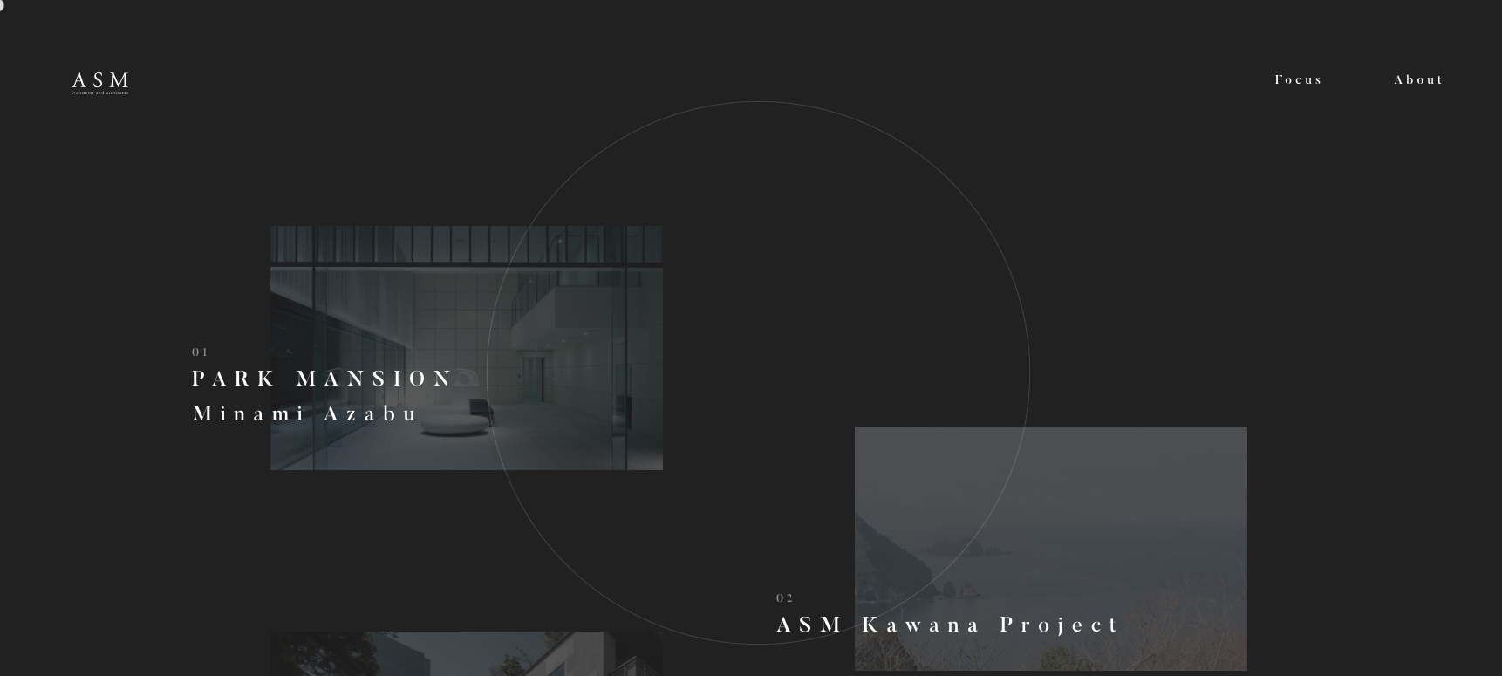

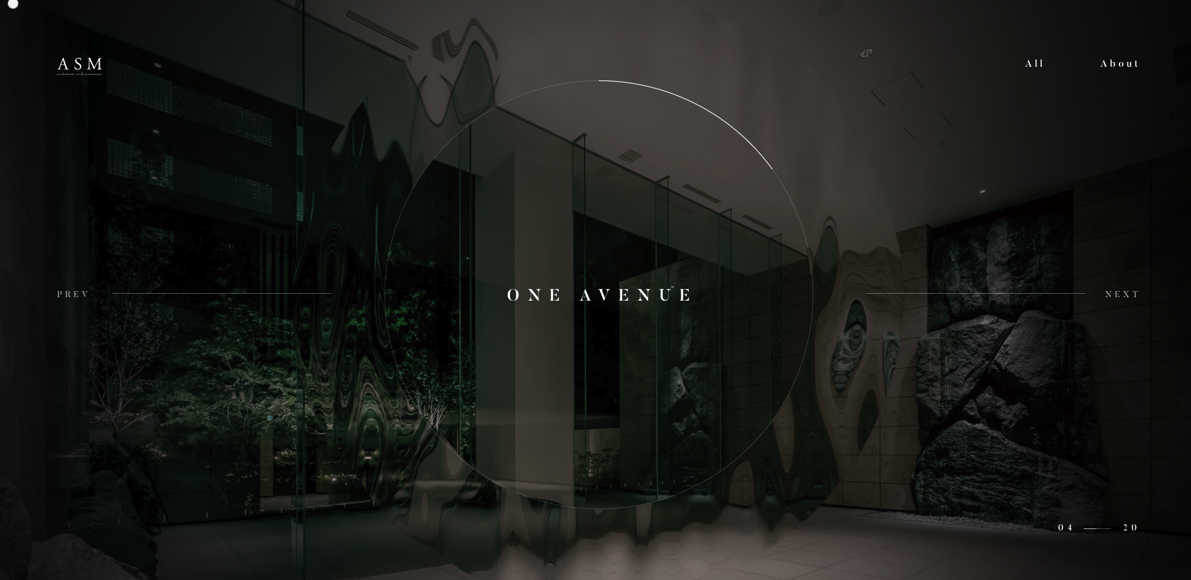

<https://niloofarnk.com/>

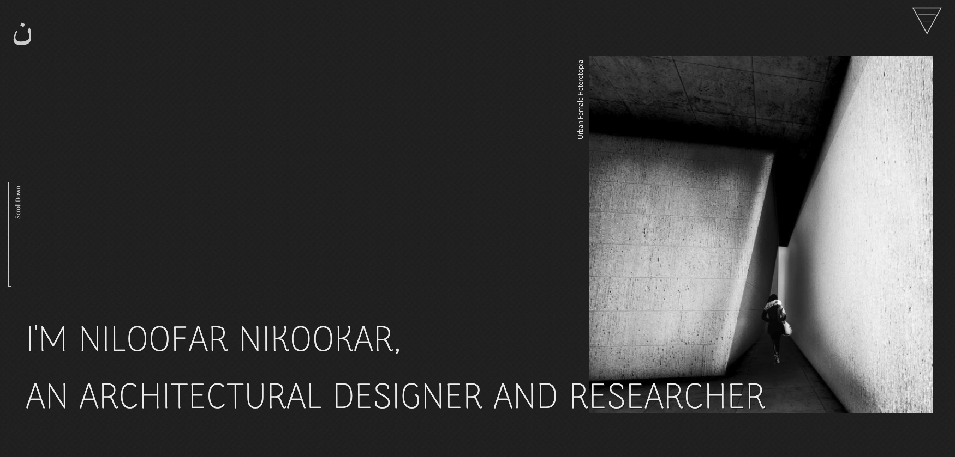

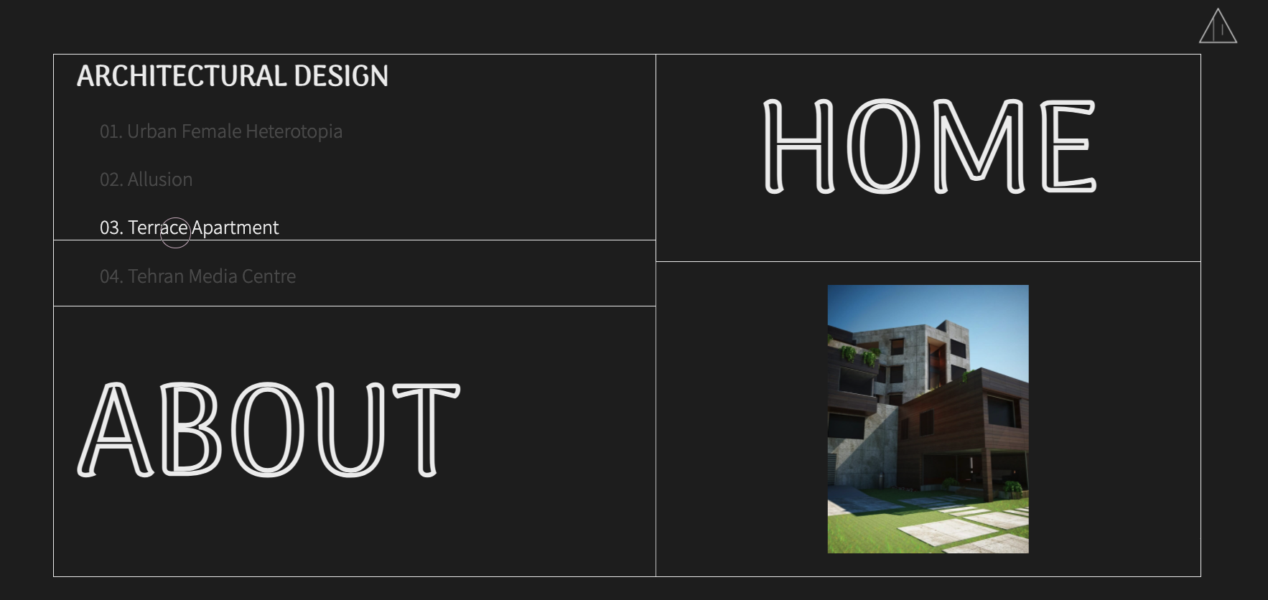

<https://www.rsh-p.com/>

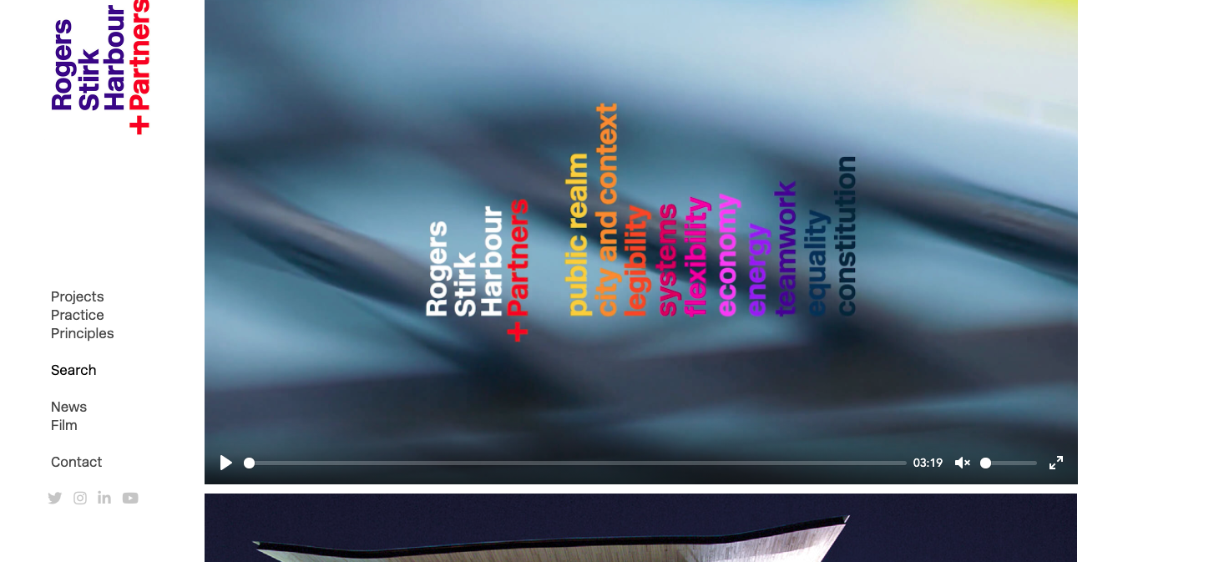

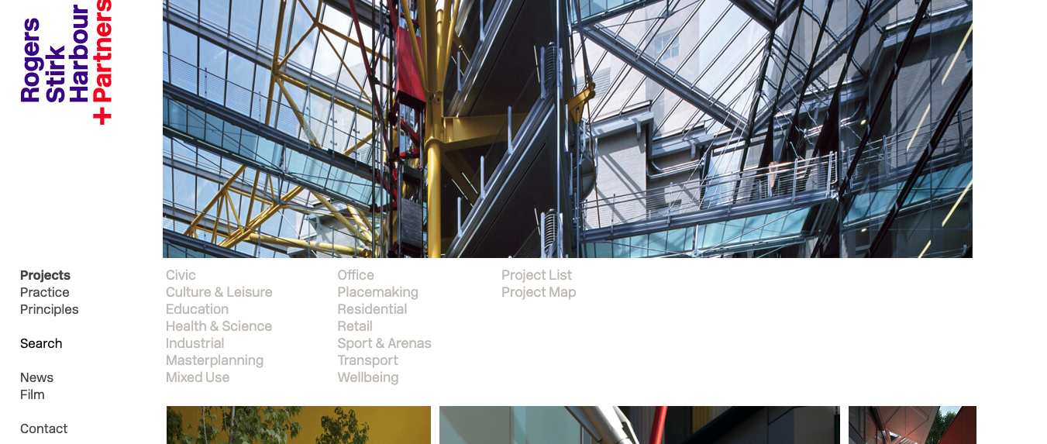

<https://www.zaha-hadid.com/>

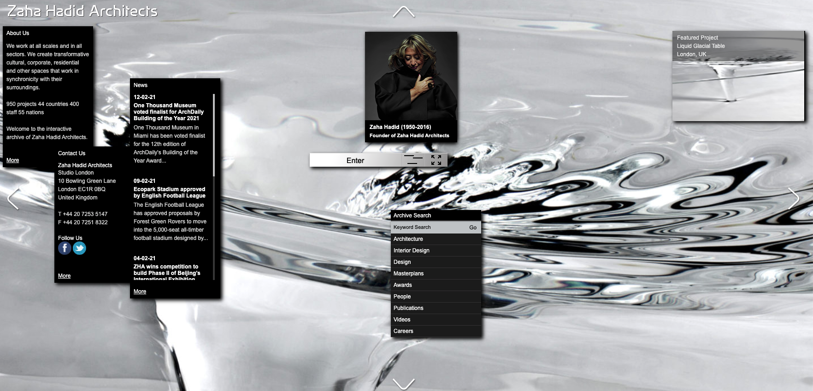

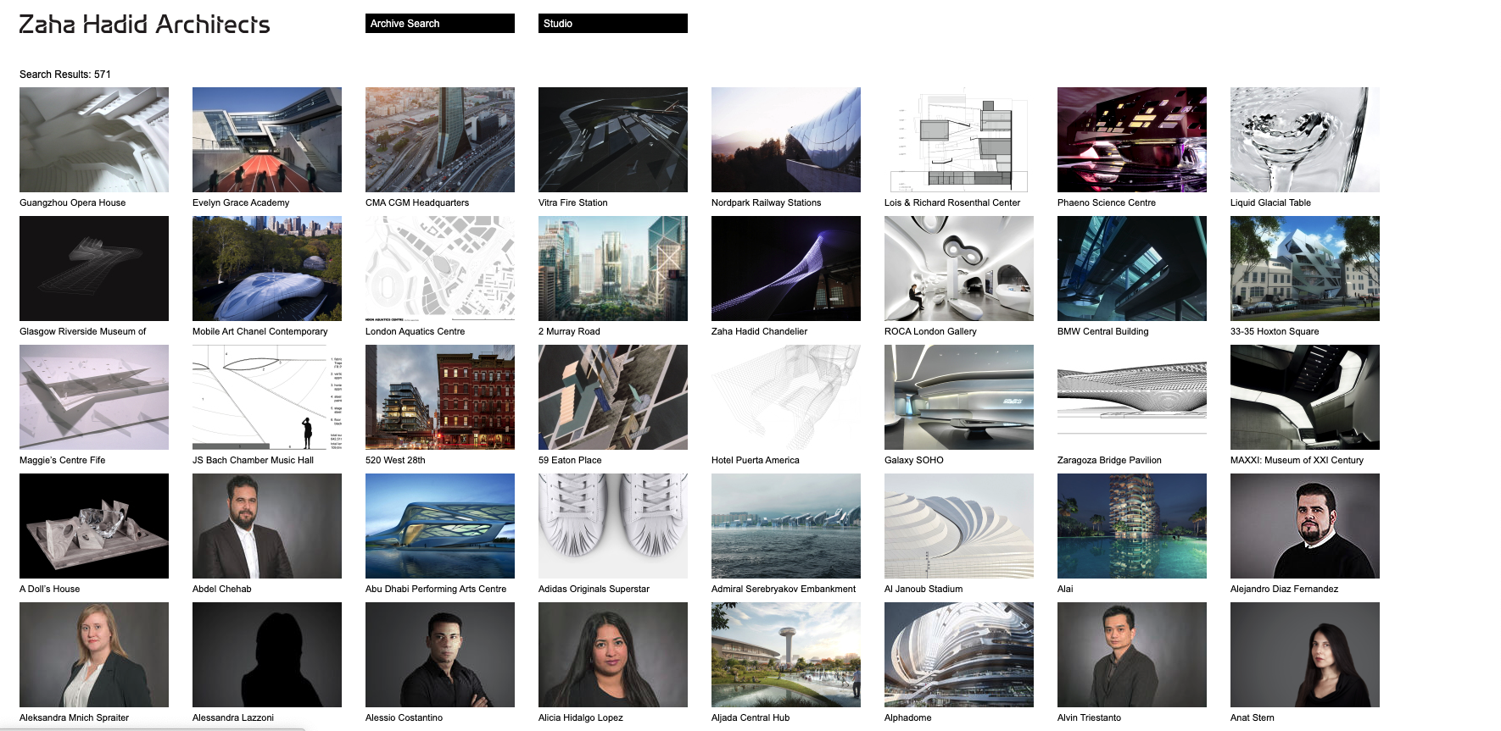

<https://www.smartdesignstudio.com/>

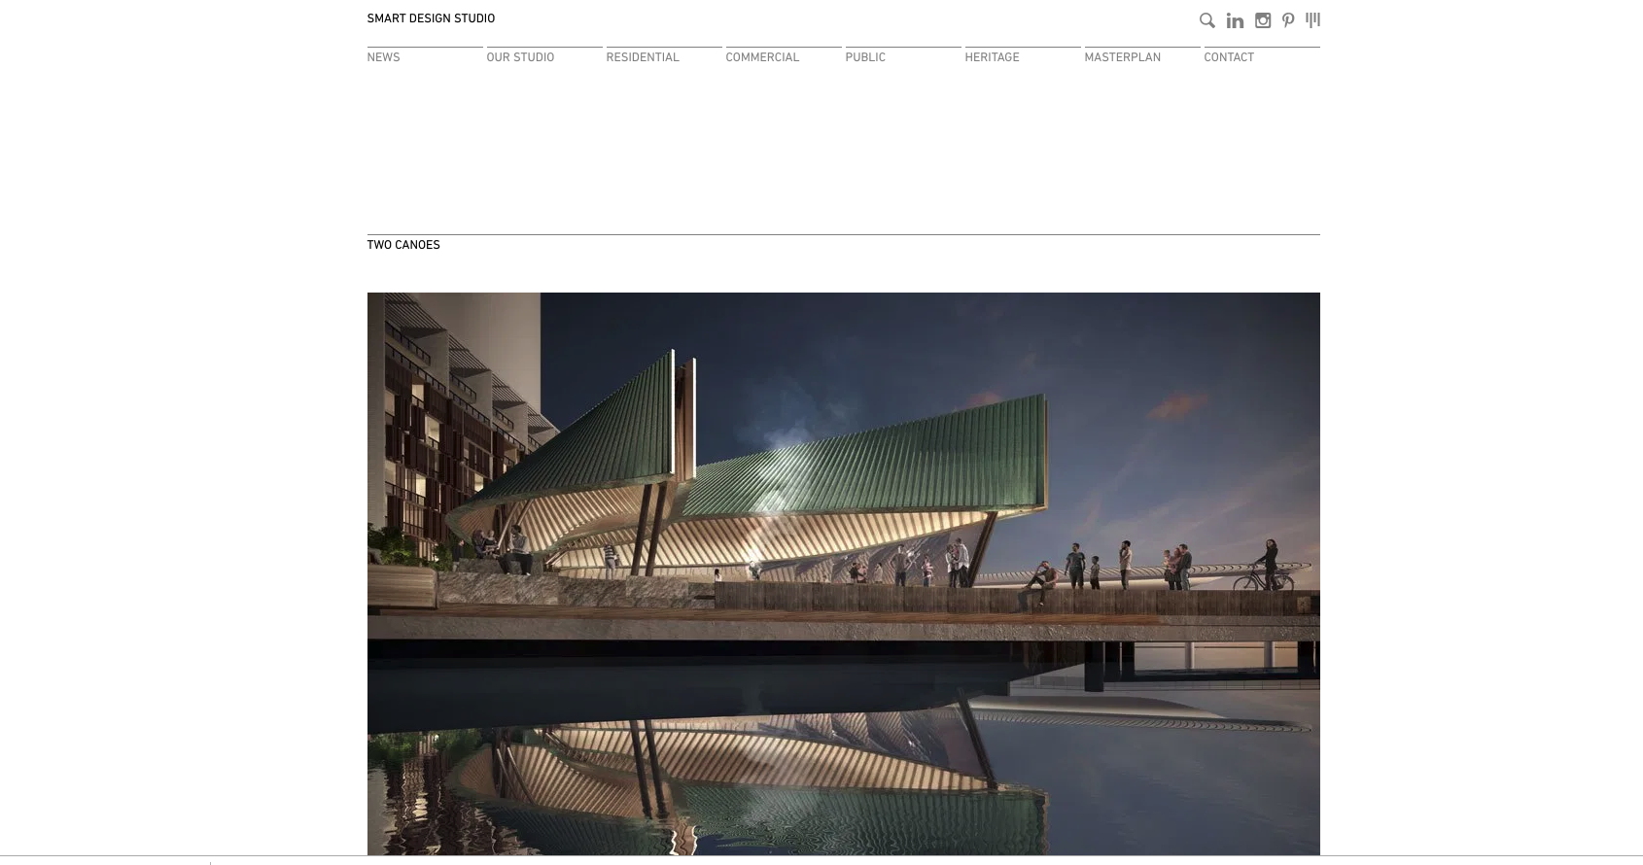

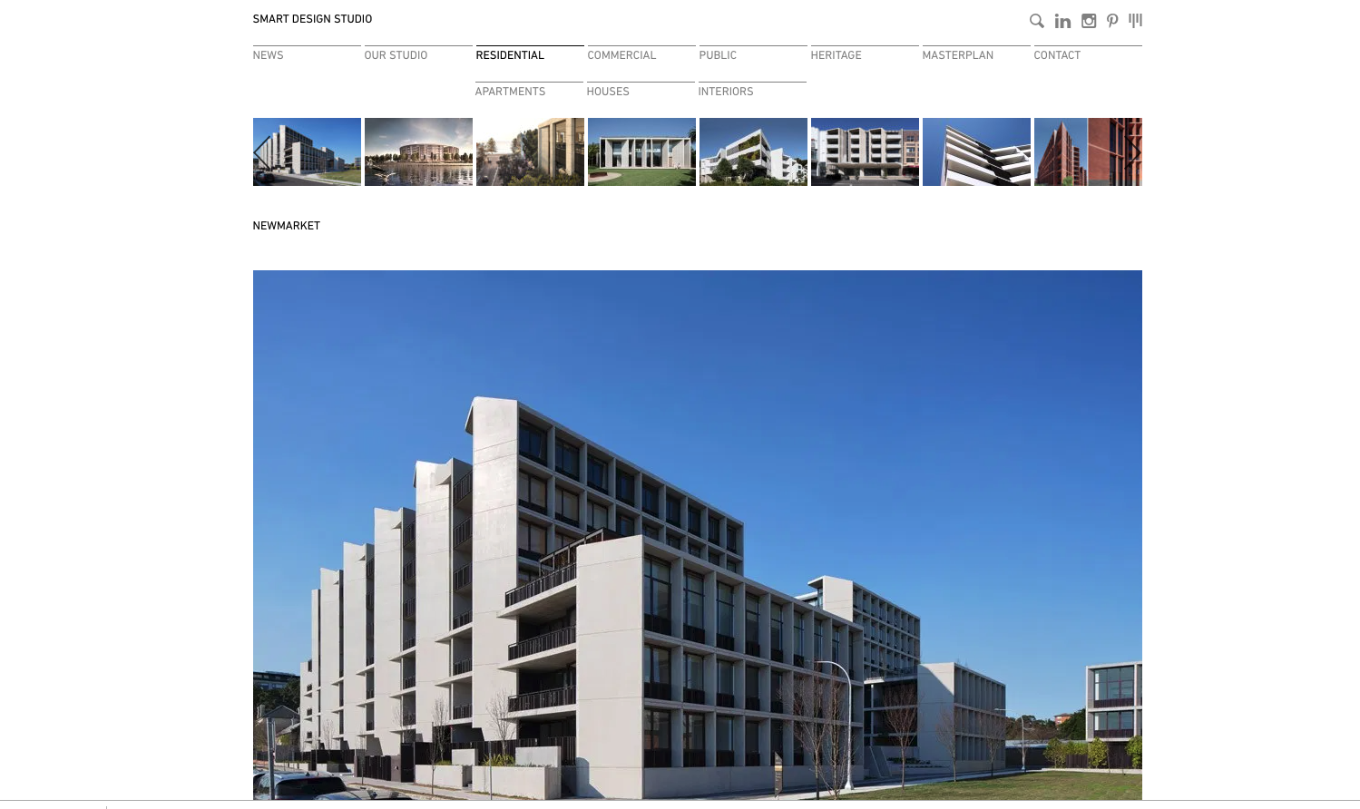

Inspiration- https://smartdesignstudio.com

Proposed ADA site map-

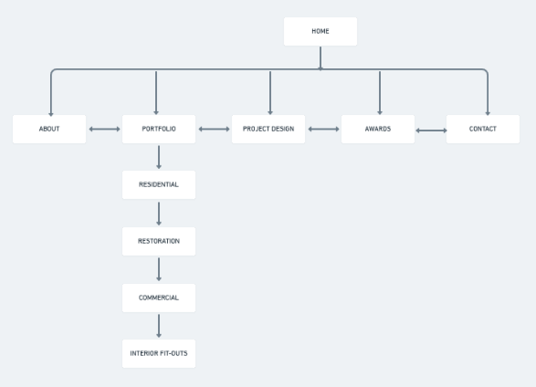

Wireframes map out the page layout-

Landing page-

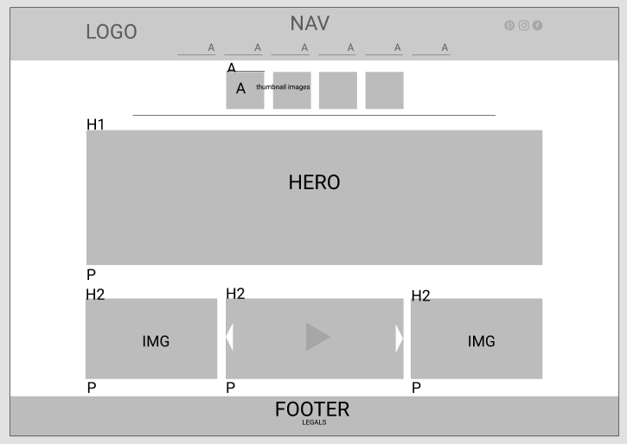

About page-

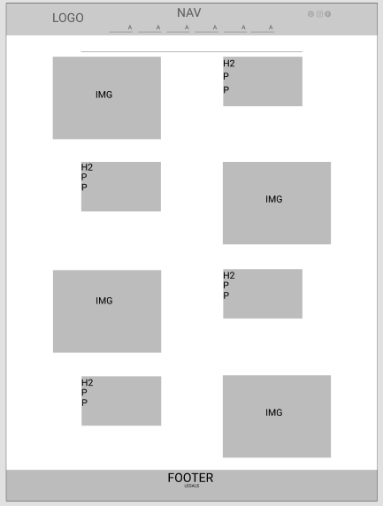

Portfolio- residential

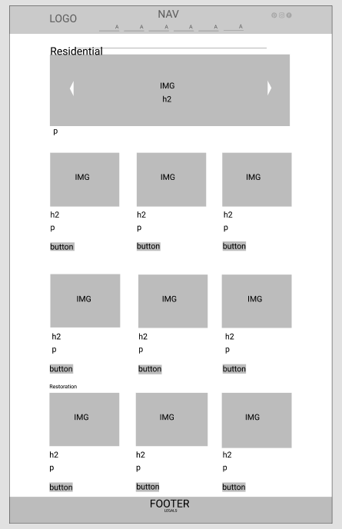

restoration

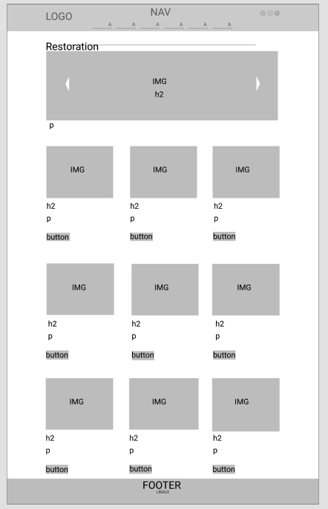

Commercial

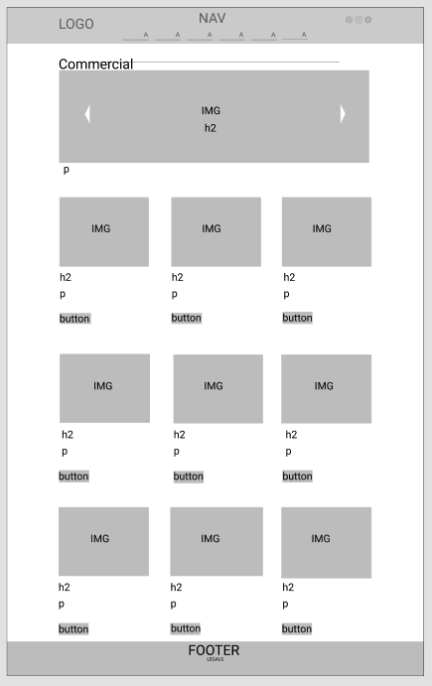

Interior fit outs

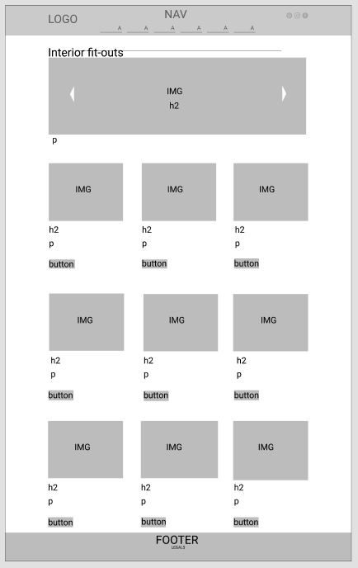

Project design

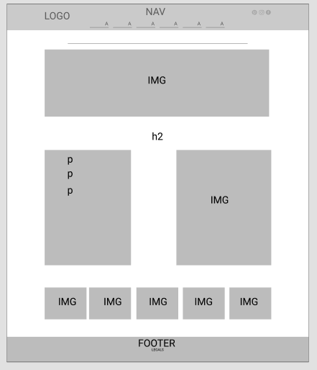

Awards

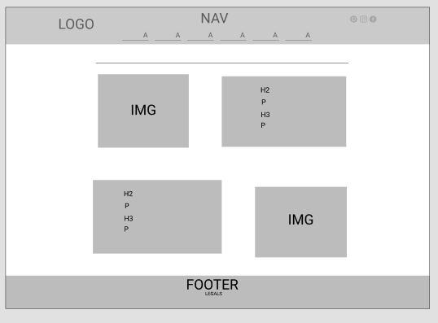

Contact

